

INCLUDEPICTURE "http://rimoftheworld.net/images/gallery/1851.thumb.jpg" \* MERGEFORMATINET

PREPARE YOUR FAMILY
Develop & Practice a
FAMILY FLOOD ACTION PLAN
Prepare your family to meet a localized flood emergency. Form a personal family plan and ensure that all household members:

Know the safest path to access high ground.
Know if they are already on high ground and where & when to stay in place.
Know an alternate shelter close to your home.
Know local emergency system broadcast information.

Emergency Alert System Stations

93.3FM KBHRBig Bear
107.7FM KCDZMorongo & Joshua
Tree
95.1FM KFRGValley & High
Desert
98.9FM KHWYHigh Desert
102.3FM KZXYVictor Valley
San Bernardino County Office of Emergency Services
(909) 356-3998
San Bernardino County: http://www.sbcounty.gov/flood
National Weather Service: http://www.wrh.noaa.gov/sgx/

Fawnskin/Big Bear Area

Family Flood Action Plan
Residents in the Fawnskin/Big Bear Area and adjacent areas need to develop and practice a Family Flood Action Plan related specifically to thunderstorms, flash flooding and debris flow potential. Know your property location in relation to natural landscape drainage. Significant water flows can develop with one quarter inch to one half inch of rain in short periods.

It is critical that residents living in and below burn areas remain aware of the unpredictability of thunderstorm activity. The National Weather Service can predict where thunderstorms are forming but not where rainfall will occur. Storms can form rapidly and be very localized. Residents need to prepare to be self reliant in the event a storm affects over their region.

Fresh burn areas contain ash and soils that do not absorb water and can create slick surfaces. Ash and debris added to storm water increases the speed, depth and distance of water flows. Use extreme caution if attempting to evacuate and never drive or walk across running water.
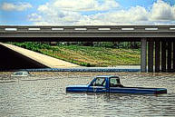
PAY CLOSE ATTENTION to all emergency notifications including the Telephone Emergency Notification System (TENS) that may be used by the County to send pre-recorded messages to home phones.
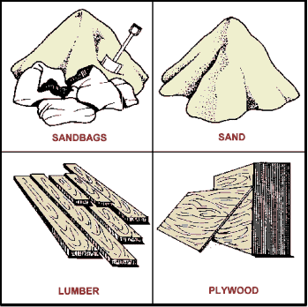
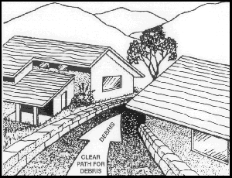
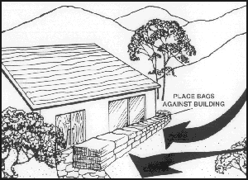
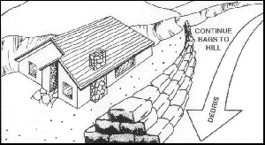
PREPARE YOUR PROPERTY
FLOOD FACTS SHEET
DEBRIS CONTROL AIDS

ARE:not expensive compared to the
protection received

CAN:be installed with normal household
tools

CONSIST:of material readily available
GENERAL RULES
Each situation differs but basic rules can be followed in all cases involving debris movement.

NEVER underestimate the power of water & debris flows
TRY to direct flows away from structures
AVOID trying to confine flows more than is absolutely required
CLEAR a path for the debris
USE buildings as deflectors if necessary
ALWAYS place protection to deflect, not to dam flows & debris
DEBRIS can enter through a window
TRY to work with adjacent affected property owners
BE prepared to sacrifice use of portions of your property to achieve good protection
Sandbags will not seal out water. Sand and soil filled burlap bags deteriorate when exposed over time to continued wetting & drying. Sandbag protection is basically for low-flow protection (up to two feet). Protection from higher flows requires more permanent diversion structures.
Source information: San Bernardino County Flood Control District http://www.sbcounty.gov/flood/
9/19/2007

